1. **SYNOPIS**

 The project entitled “**ONLINE COURSE PORTAL**” will be developed using **ASP.NET** and back end is **SQL database**. This software is developed in such a way, so the user can do continues transaction fast and efficiently. There are 3 types of users in this software admin, instructor and student. This allows registered users of the system to join a course available in the site and access the materials published for the course.

The main objective of the project to provide online course so that user can access the course from any part of the world. There will be mechanism to create a test for the test.

Due to the implementation for the course portal online, admissions into the selected courses are made with an ease by optimizing the time.

1. **INTRODUCTION**

Online course portal is software developed for student in schools, colleges and institutes to access online course material. The project aims at creating a courses portal for a organization. This allows registered users of the system to join a course available in the site and access the materials published for the course. People can register themselves as students of a course or Faculty for the course. It facilitates to access the information of a particular course. The information is provided by the teacher for a particular course. The purpose of developing software is to computerized the tradition way of taking class.

**2.1 Introduction to .Net**

The .NET platform is an integral component of the Microsoft Windows operating system for building and running next generation software applications and Web services. Microsoft .NET is a framework that provides a common platform to execute or run the applications developed in various programming languages. The main intention was to bridge the gap in interoperability between services of various programming languages.

As security is an essential part of .NET, it provides security support, such as code authenticity check, resources access authorizations, declarative and imperative security, and cryptographic security methods for embedding into the user’s application.

**.NET Framework**

.NET Framework includes large class library known as Framework Class Library(FCL) and provides language interoperability across programming languages. Programs written for .NET Framework execute in a software environment known as Common Language Runtime (CLR).

CLR is an application virtual machine that provides services such as security, memory management, and exception handling. FCL and CLR together constitute .NET Framework. FCL provides user cryptography, web application development, numeric and network

.NET Framework is intended to be used by most new applications created for the Windows platform. Microsoft also produces an integrated development environment largely for .NET software called Visual Studio.

In computer science, a library is a collection of non-volatile resources used by computer programs, often to develop software. Language interoperability is the capability of two different programming languages to natively interact and operate on the same kind of data structures.

An integrated development environment (IDE) is a software application that provides comprehensive facilities to computer programmers for software development. An IDE normally consists of a source code editor and a debugger. Most modern IDEs have intelligent code completion. Some IDEs, such as NetBeans and Eclipse, contain a compiler, interpreter or both.

**Common Language Infrastructure (CLI)**

Common Language Infrastructure (CLI) provides a language-neutral platform for application development and execution, including functions for exception handling, garbage collection, security, and interoperability.

Microsoft's implementation of CLI is Common Language Runtime (CLR). It serves as the execution engine of .NET Framework. All .NET programs execute under the supervision of CLR, guaranteeing certain properties and behaviors in the areas of memory management, security, and exception handling.

For computer programs to run on CLI, they need to be compiled into Common Intermediate Language (CIL) – as opposed to being compiled into machine code. Upon execution, an architecture-specific just-in-time compiler (JIT) turns the CIL code into machine code.

**Common Language Runtime (CLR)**

The Common Language Runtime (CLR), the virtual machine component of Microsoft's .NET framework, manages the execution of .NET programs.

A process known as just-in-time compilation converts compiled code into machine instructions which the computer's CPU then executes.

The CLR provides additional services including loading and execution of the programs, memory isolation for applications, compilation of IL into native executable code, providing metadata, memory management, type safety, exception handling, garbage collection, security enforcement and thread management. All programs written for the .NET framework, regardless of programming language, are executed by the CLR.

**Common Type System (CTS)**

.NET framework provides multiple language support using the feature known as Common Type System (CTS) that is built into CLR.

The common type system defines how types are declared, used, and managed in the common language runtime, and is also an important part of the runtime's support for cross-language integration. CTS supports a variety of types and operations found in most programming languages & therefore calling one language from other does not need type conversion.

**Common Language Specification (CLS)**

The common language specification defines a set of rules that enables interoperability on the .NET platform.

CLS is the subset of CTS and thus the languages supporting the CLS can use of each other’s class libraries.

**Microsoft Intermediate Language (MSIL)**

It is an instruction set into which all the .NET programs are compiled. It is akin to assembly language and contains instructions for loading, storing and initializing and calling methods. When we compile a C# program or any program written in a CLS compliant language, the source code is compiled into MSIL.

MSIL was formerly called as Common Intermediate Language.

* 1. **Introduction to ASP.NET**

ASP stands for Active Server Pages. ASP is a development framework for building web pages. ASP.NET is a web development platform, which provides a programming model, a comprehensive software infrastructure and various services required to build up robust web applications for PC, as well as mobile devices.

ASP.NET works on top of the HTTP protocol, and uses the HTTP commands and policies to set a browser-to-server bilateral communication and cooperation.

ASP.NET is a part of Microsoft .Net platform. ASP.NET applications are compiled codes, written using the extensible and reusable components or objects present in .Net framework. These codes can use the entire hierarchy of classes in .Net framework.

The ASP.NET application codes can be written in any of the following languages – C#, Visual Basic.Net, Jscript, J#.

ASP.NET is used to produce interactive, data-driven web applications over the internet. It consists of a large number of controls such as text boxes, buttons, and labels for assembling, configuring, and manipulating code to create HTML pages.

**ASP.NET Web Pages**

Web Pages is one of many programming models for creating ASP.NET web sites and web applications. Web Pages provides an easy way to combine HTML, CSS, and server code.

**ASP.NET Web Forms**

ASP.NET Web Forms is an event driven application model. Web Forms are pages that your users request using their browser. These pages can be written using a combination of HTML, client-script, server controls, and server code.

* 1. **Introduction to C SHARP (#) Language**

C# is a modern object-oriented, general-purpose programming language, created and developed by Microsoft together with the .NET platform. There is highly diverse software developed with C# and on the .NET platform: office applications, web applications, websites, desktop applications, mobile applications, games and many others.

The first version of C# was developed by Microsoft between 1999 and 2002 and was officially released to the public in 2002 as a part of the .NET platform. The .NET platform aims to make software development for Windows easier by providing a new quality approach to programming, based on the concepts of the "virtual machine" and "managed code".

C# is a modern, general-purpose, object-oriented, high-level programming language. Its syntax is similar to that of C and C++ but many features of those languages are not supported in C# in order to simplify the language, which makes programming easier. The C# programs consist of one or several files with a .cs extension, which contain definitions of classes and other types. These files are compiled by the C# compiler (csc) to executable code and as a result assemblies are created, which are files with the same name but with a different extension. (.exe or .dll)

Nowadays C# is one of the most popular programming languages. It is used by millions of developers worldwide. Because C# is developed by Microsoft as part of their modern platform for development and execution of applications, the .NET Framework, the language is widely spread among Microsoft-oriented companies, organizations and individual developers.

* 1. **Introduction to SQL Server 2010**

Microsoft SQL Server is a relational database management system developed by Microsoft. As a database server, it is a software product with the primary function of storing and retrieving data as requested by other software applications - which may run either on the same computer or on another computer across a network (including the Internet

**3.SYSTEM ANAYSIS**

**3.1 Existing System**

The current framework is a manual procedure which results in following issues:

* More man power
* Time consuming
* Students should come to class
* Needs manual calculations of test marks
* No direct role of higher officials
* Consumes large volume of pare work
* The procedure is extremely tedious

Hence, to override these issues proposed system is introduced

**3.2 PROPOSED SYSTEM**

The proposed system is mainly useful in conducting the online course. The proposed system is performed in ASP.net because it is user friendly and it is easy to conduct the online course in quick format. It includes various course so that the user can participate in any particular course. Hence the time duration of taking up test is very important. The user has to be complete within a time otherwise it will automatically submit the unanswered with answer ones to database.

User can choose the desired course among the available courses. First user has to login using login IDs and passwords, this process is done for authentication and also it is used for differentiating users and for providing unique results. Whenever the course is completed the report is shown immediately. In the proposed system it is able to see a particular participant performance.

**List of modules used in this project are explained below:**

* **Admin module**
* **Instructor module**
* **User/student module**

**Admin Module:**

* Admin can add course
* Admin can add instructor
* Admin can approve feedback
* Admin can assign course to instructor
* Admin can assign course to student
* Admin can add contact details
* Admin can view the registered users
* Admin can view the feedbacks given by user

**Instructor Module:**

* Instructor has to login as instructor
* Instructor can upload videos
* Instructor can upload pdf document
* Instructor can create test
* Instructor view the uploaded videos and pdf document
* Instructor can change password

**User Module:**

* User has to register for login
* User can view the course
* User can select course
* User can make payment for a course
* User can select payment type
* User can view video and pdf document for course which user payed
* User can give feedback
* User can view feedback
* User can change password

**4.ENVIRONMENT SPECIFICATION**

**4.1 HARDWARE REQUIREMENTS**

HARD DISK : 1 TB

MONITOR : Lenovo Monitor

RAM : 4.00 GB

PROCESSOR : Intel® Core™ i3 - 4005 CPU @ 1.70GHz

**4.2 SOFTWARE REQUIREMENTS**

OPERATING SYSTEM : Windows 7 or higher version

TOOLS : Microsoft Visual Studio-2010

CLIENT : Microsoft Internet Explorer

FRONT END : ASP.NET

CODING LANGUAGE : C#

BACK END : SQL Server 2012

1. **SYSTEM DESIGN**

**5.1 ER – Diagram**

Dfd

**4.3 DATABASE TABLES**

**AddCourse**

|  |  |  |  |
| --- | --- | --- | --- |
| **Field Name** | **Data Type** | **Size** | **Constraints** |
| CourseID | Int | 20 | Primary key |
| CourseName | Real | 10 | Not null |
| FeeOfCourse | Decimal | 18 | Not null |
| InstractorName | Nvarchar | 200 | Not null |
| FromDate | Datetime |  | Not null |
| ToDate | Datetime |  | Not null |
| Delrec | Nvarchar | 1 | Not null |
| LastModified | Nvarchar | 200 | Not null |
| LastUpdatedTime | Nvarchar | 200 | Not null |
| CourseAvilable | Varchar | 20 | Not null |

**AssignedCourseForStudents**

|  |  |  |  |
| --- | --- | --- | --- |
| **Field Name** | **Data Type** | **Size** | **Constraints** |
| StuCouAssignID | Int | 20 | Primary key |
| CourseName | Varchar | max | Not null |
| InstractorName | Nvarchar | max | Not null |
| StudentName | Nvarchar | max | Not null |
| Stuid | Int |  | Not null |
| Assigned | Nvarchar | 3 | Not null |
| Delrec | Nvarchar | 1 | Not null |

|  |  |  |  |
| --- | --- | --- | --- |
| **Field Name** | **Data Type** | **Size** | **Constraints** |
| LocationID | Int | 30 | Primary key |
| LocationName | nvarchar | 50 | Not null |
| ContactNum | nvarchar | 50 | Not null |
| EmailID | nvarchar | 50 | Not null |
| LandLineNum | nvarchar | 50 | Not null |
| Delrec | nvarchar | 1 | Not null |

**ContactUs**

**CustomerFeedBack**

|  |  |  |  |
| --- | --- | --- | --- |
| **Field Name** | **Data Type** | **Size** | **Constraints** |
| FedID | Int | 20 | Primary key |
| Name | nvarchar | 200 | Not null |
| Coursename | nvarchar | 200 | Not null |
| EmailID | nvarchar | 200 | Not null |
| Comments | nvarchar | max | Not null |
| MobileNumber | nvarchar | 13 | Not null |
| Ratting | nvarchar | 1 | Not null |
| Delrec | nvarchar | 1 | Not null |

**DocumentUploadWRTCourse**

|  |  |  |  |
| --- | --- | --- | --- |
| **Field Name** | **Data Type** | **Size** | **Constraints** |
| DocumentID | Int | 20 | Primary key |
| CourseName | Nvarchar | max | Not null |
| AuthorName | Nvarchar | max | Not null |
| DocumentLink | Nvarchar | max | Not null |
| Created | Datetime |  | Not null |
| LastModified | Datetime |  | Not null |
| Delrec | Nvarchar | 1 | Not null |

**OnlineStudyBooklogin**

|  |  |  |  |
| --- | --- | --- | --- |
| **Field Name** | **Data Type** | **Size** | **Constraints** |
| Eid | Int | 20 | Primary key |
| Etype | nvarchar | 1 | Not null |
| Uname | nvarchar | 50 | Not null |
| Password | nvarchar | 20 | Not null |
| Email | nvarchar | 50 | Not null |
| Delrec | nvarchar | 1 | Not null |
| Lastupdate | datetime |  | Not null |
| Lastedit | Nvarchar | 50 | Not null |
| instAvailable | Nvarchar | 5 | Not null |

**Paymentdetails**

|  |  |  |  |
| --- | --- | --- | --- |
| **Field Name** | **Data Type** | **Size** | **Constraints** |
| Pid | Int | 20 | Primary key |
| CourseName | nvarchar | 200 | Not null |
| LoginId | Int | 50 | Not null |
| Studentname | nvarchar | 200 | Not null |
| Approval | Nchar | 1 | Not null |
| Paytype | nvarchar | 2 | Not null |
| Bankname | nvarchar | 50 | Not null |
| Bankaccno | decimal | 18 | Not null |
| Paydate | Date |  | Not null |
| Delrec | Nchar | 1 | Not null |
| Cardno | nvarchar | max | Not null |
| Assigned | nvarchar | 20 | Not null |

**tblQuestions**

|  |  |  |  |
| --- | --- | --- | --- |
| **Field Name** | **Data Type** | **Size** | **Constraints** |
| QuestionId | Int | 20 | Primary key |
| Question | nvarchar | 500 | Not null |
| Option1 | nvarchar | 255 | Not null |
| Option2 | nvarchar | 255 | Not null |
| Option3 | nvarchar | 255 | Not null |
| Option4 | nvarchar | 255 | Not null |
| QuestionAnswer | nvarchar | 255 | Not null |
| courseName | nvarchar | Max | Not null |
| Delrec | nvarchar | 1 | Not null |

**VideoUploadWRTCourse**

|  |  |  |  |
| --- | --- | --- | --- |
| **Field Name** | **Data Type** | **Size** | **Constraints** |
| VideoID | Int | 20 | Primary key |
| CourseName | nvarchar | max | Not null |
| AuthorName | nvarchar | max | Not null |
| VideoLink | nvarchar | max | Not null |
| Created | datetime |  | Not null |
| LastModified | nvarchar | 200 | Not null |
| Delrec | nvarchar | 1 | Not null |
| courseName | nvarchar | max | Not null |
| Session | nvarchar | max | Not null |

|  |  |  |  |
| --- | --- | --- | --- |
| **Field Name** | **Data Type** | **Size** | **Constraints** |
| MarcksID | Int | 20 | Primary key |
| StudentName | nvarchar | 50 | Not null |
| Subject | nvarchar | 50 | Not null |
| MarksObtained | Int | max | Not null |
| StatusOfTest | Int | Max | Not null |
| Delrec | nvarchar | 1 | Not null |

**MarksCard**

1. **SYSTEM TESTING AND IMPLEMENTATION**

Software testing is a critical element of software quality assurance and represents the ultimate review of specification, design and coding. In fact, testing is the one step in the software engineering process that could be viewed as destructive rather than constructive.

A strategy for software testing integrates software test case design methods into a well-planned series of steps that result in the successful construction of software. Testing is the set of activities that can be planned in advance and conducted systematically. The underlying motivation of program testing is to affirm software quality with methods that can economically and effectively apply to both strategic to both large and small-scale systems.

#### Types of testing:

##### **Unit Testing:** Unit testing is the testing of an individual unit or group of related units. It falls under the class of white box testing. It is often done by the programmer to test that the unit he/she has implemented is producing expected output against given input.

##### **Integration Testing:** Integration testing is testing in which a group of components are combined to produce output. Also, the interaction between software and hardware is tested in integration testing if software and hardware components have any relation. It may fall under both white box testing and black box testing.

##### **Functional Testing** Functional testing is the testing to ensure that the specified functionality required in the system requirements works. It falls under the class of black box testing.

##### **System Testing** System testing is the testing to ensure that by putting the software in different environments (e.g., Operating Systems) it still works. System testing is done with full system implementation and environment. It falls under the class of black box testing.

##### **Performance Testing** Performance testing is the testing to assess the speed and effectiveness of the system and to make sure it is generating results within a specified time as in performance requirements. It falls under the class of black box testing.

**Test Cases**

1. **REGISTRATION PAGE**

|  |  |  |
| --- | --- | --- |
| **Test Id** | **Test Condition** | **Result** |
| 1.1 | When none of the fields are entered and the register button is clicked( RequiredFieldValidator is used) | A message appears which asks you to enter the details. |
| 1.2 | When the email id is not entered in the proper format and the submit button is clicked.  ( RegularExpressionValidator is used) | A message appears which asks you to enter the valid email id |
| 1.3 | When the username is not and the submit button is clicked.  (RequiredFieldValidator ir is used) | A message appears which says username required |
| 1.5 | When the confirm password is not entered  (CompareValidator is used) | A message appears which says password mismatch |

1. **LOGIN**

|  |  |  |
| --- | --- | --- |
| **Test Id** | **Test Condition** | **Result** |
| 2.1 | When the correct username ,password and user type is entered and the submit button is clicked | It is redirected to the corresponding pages |
| 2.2 | When the incorrect username, password is entered and the submit button is clicked | A message which says Invalid details |
| 2.3 | When the submit is clicked without entering the contents | A message appears which says Invalid details |
| 2.4 | When the new user link is clicked | It is redirected to the registration page |

1. **ADMIN LOGIN**

|  |  |  |
| --- | --- | --- |
| **Test Id** | **Test Condition** | **Result** |
| 3.1 | When the correct name and password is entered and the submit button is clicked | It is redirected to the corresponding pages |
| 2.1 | When the incorrect name and password is entered and the submit button is clicked | A message which says Invalid name and password |
| 2.2 | When the submit is clicked without entering the contents | A message appears which says required  name and enter valid password |

**7.SCREENSHOTS**

**IntraductionLogin.aspx**

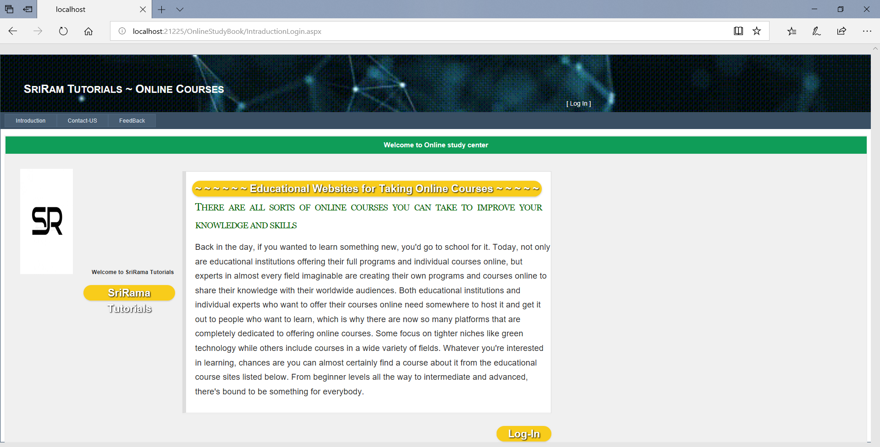

**ContactUS.aspx**

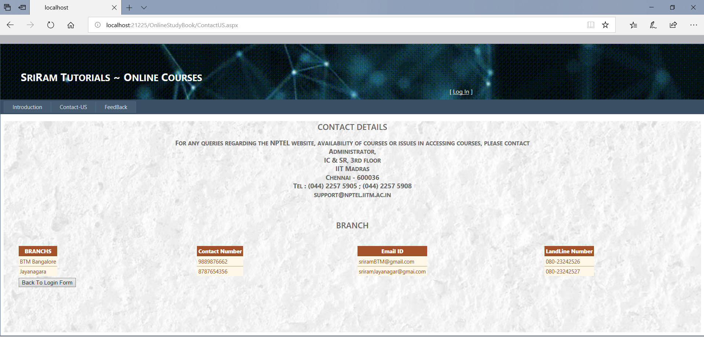

**Userregestration.aspx**

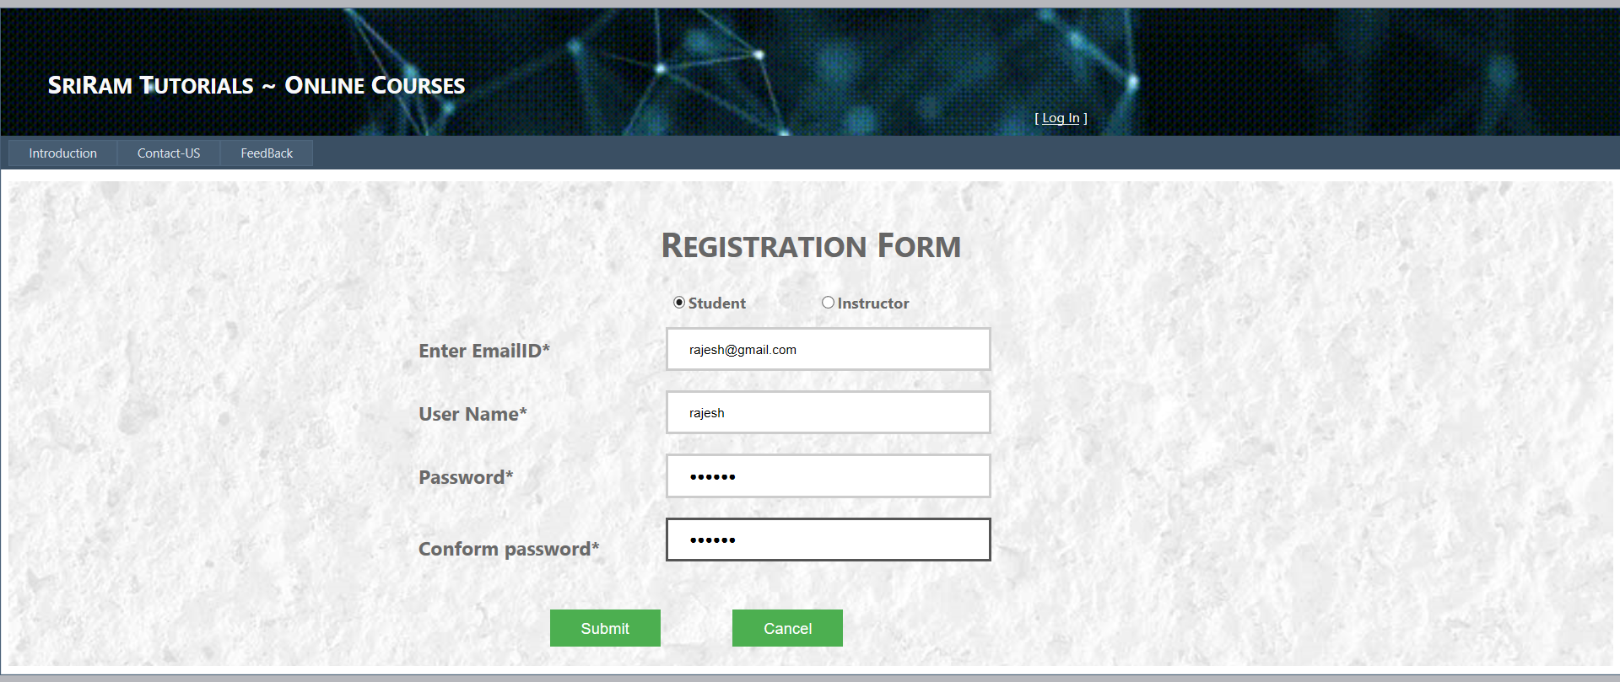

**AddCourse.aspx**

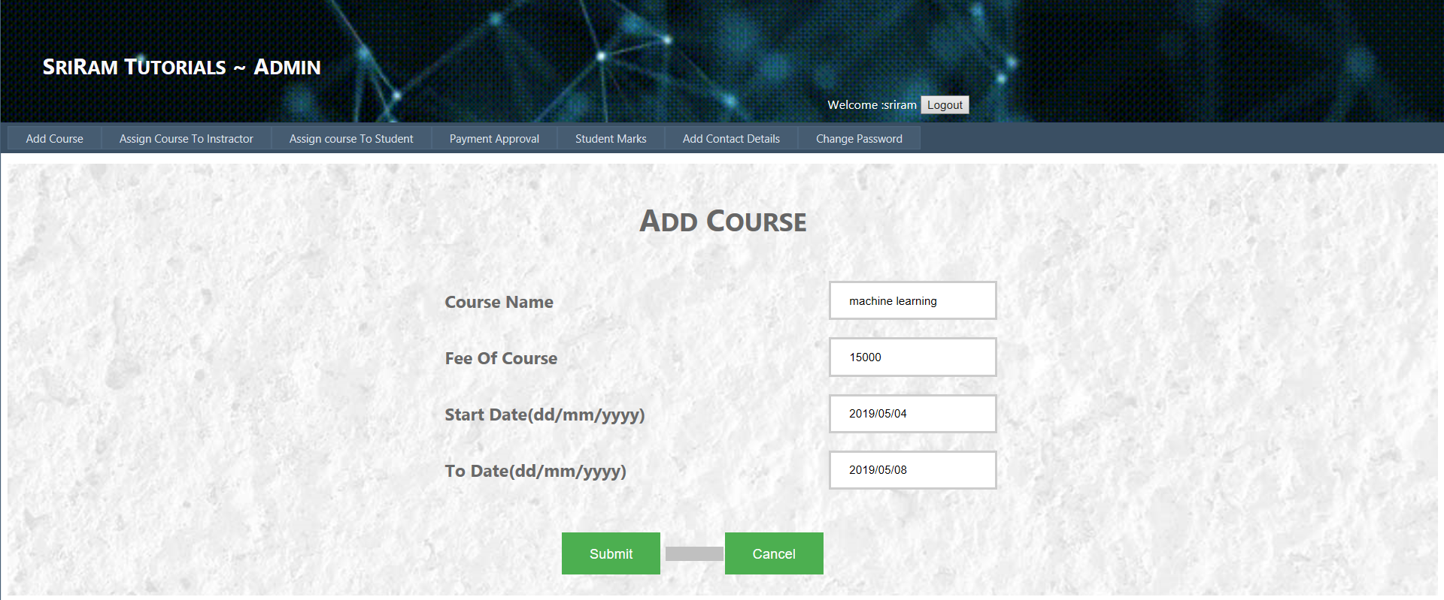

**AssignCOurseToInstractor.aspx**

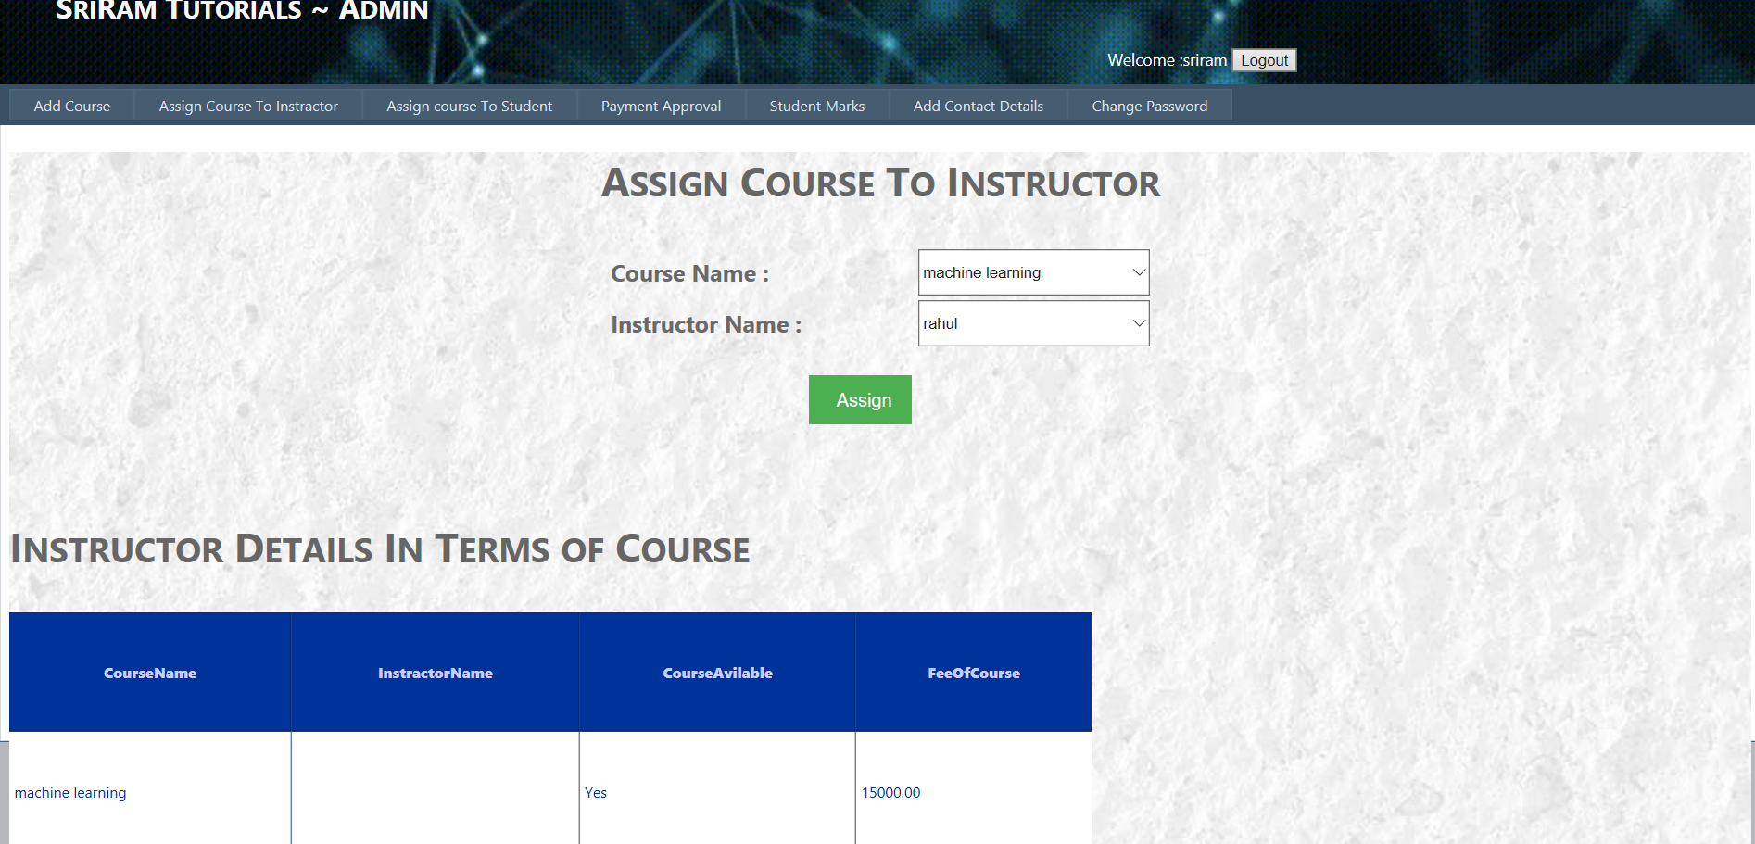

**DisplayAvailableCourse.aspx**

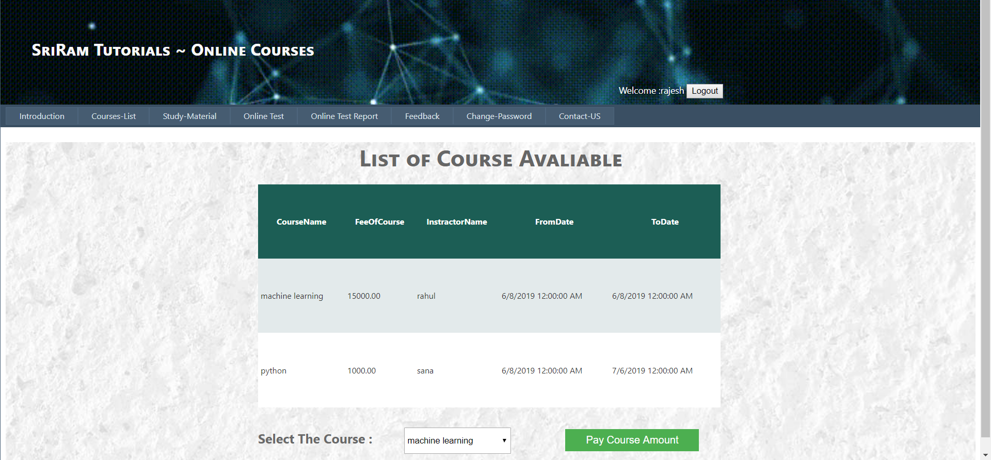

**PaymentMode.aspx**

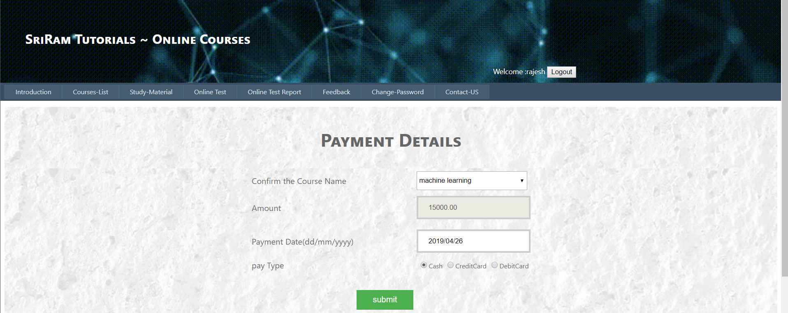

**PaymentApprovalForStudent.aspx**

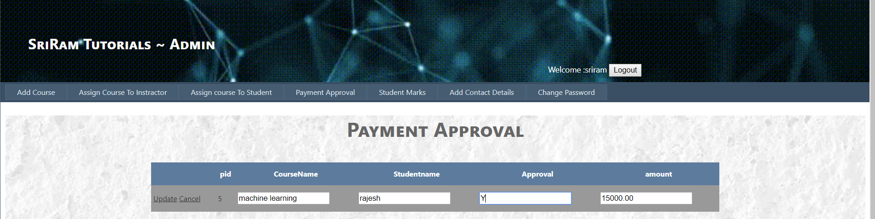

**AssignCourceToStudent.aspx**

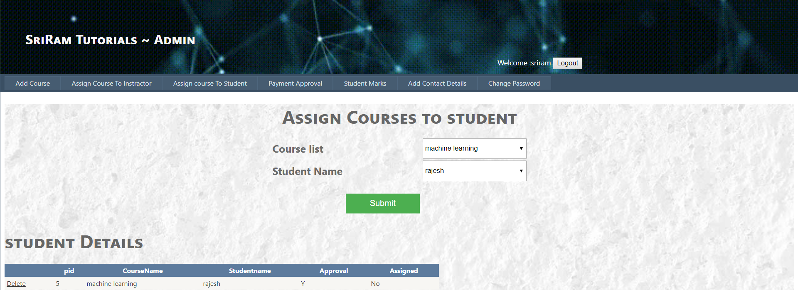

**AddContactDetails.aspx**

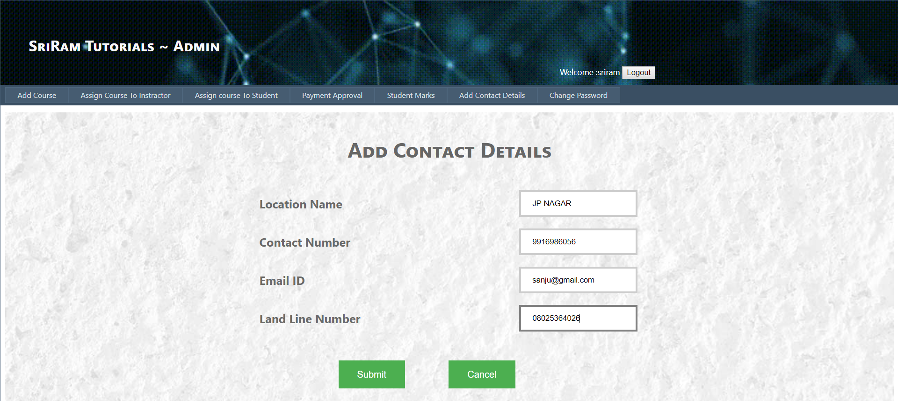

**ChangePasswordAdmin.aspx**

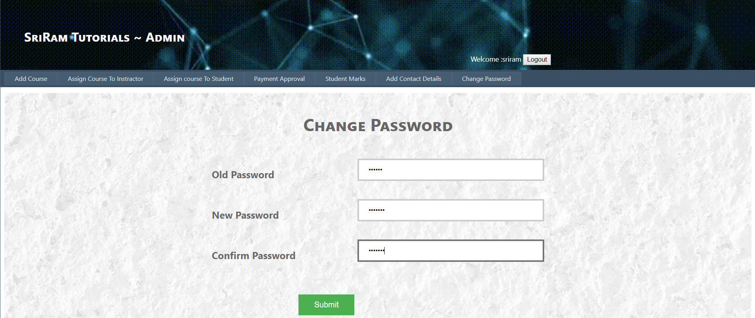

**UploadVideos.aspx**

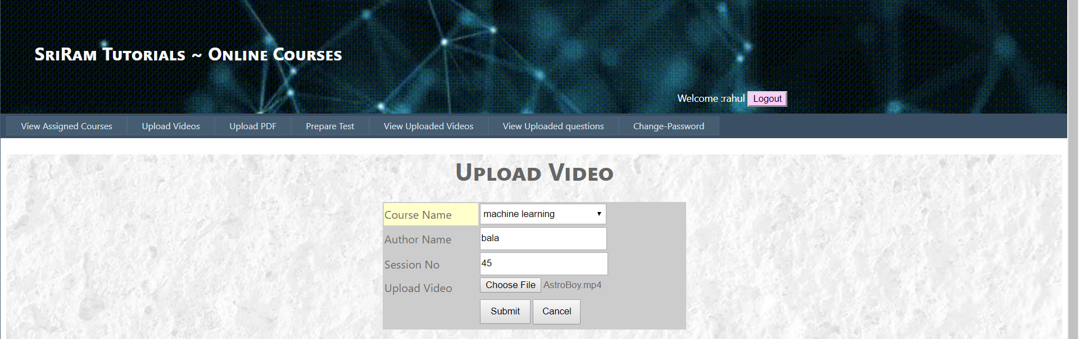

**UploadPDF.aspx**

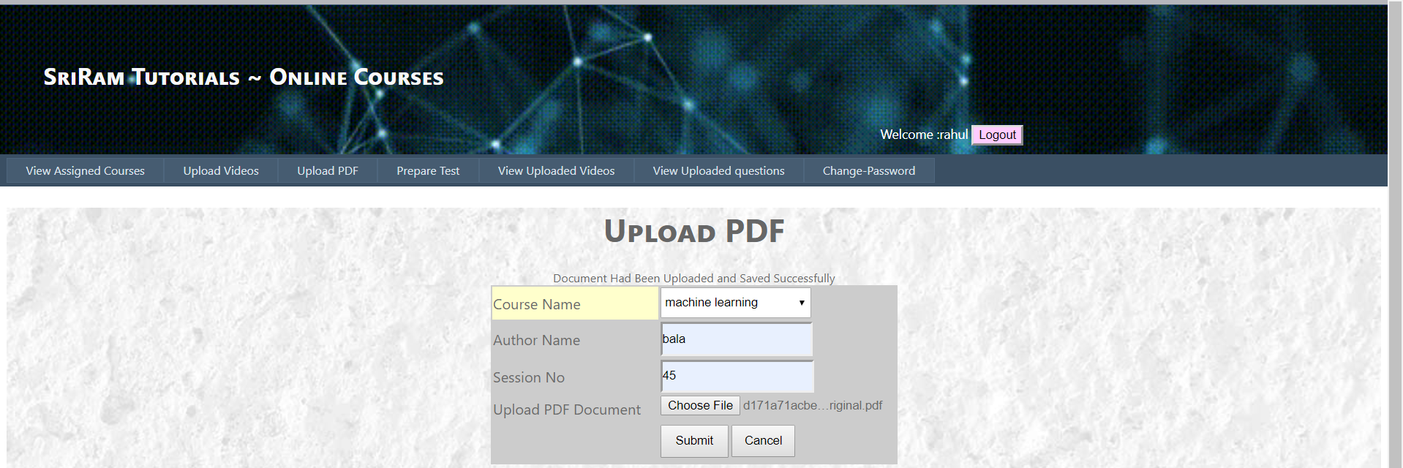



**ViewUploadedVideos.aspx**

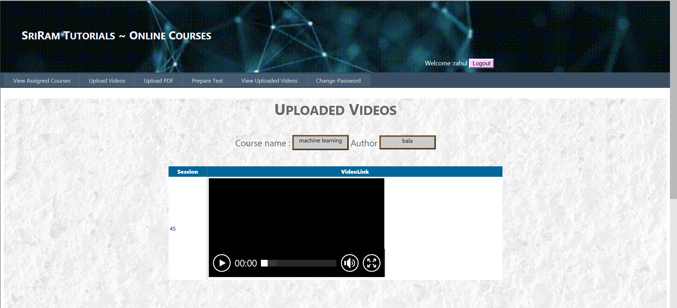

**PrepareTest.aspx**

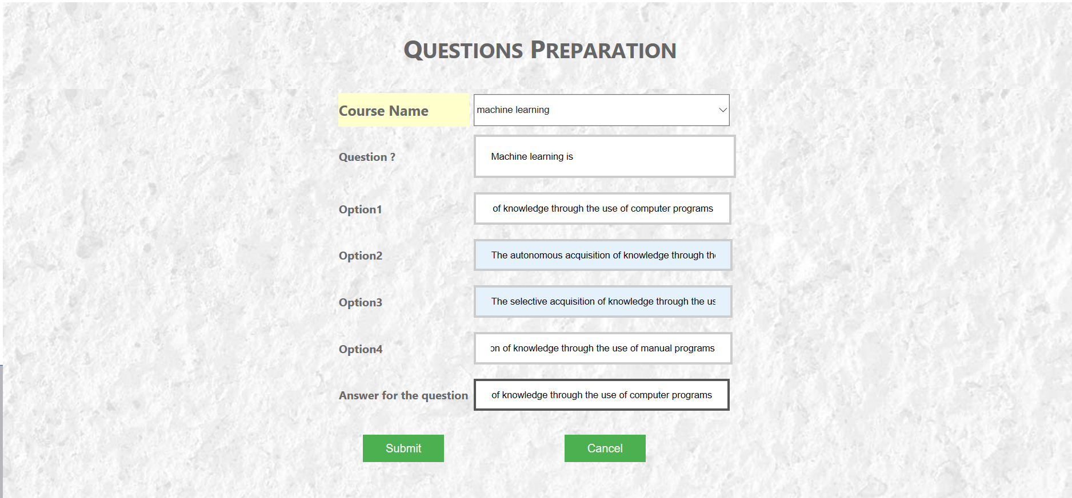

**StudyMatirials.aspx**

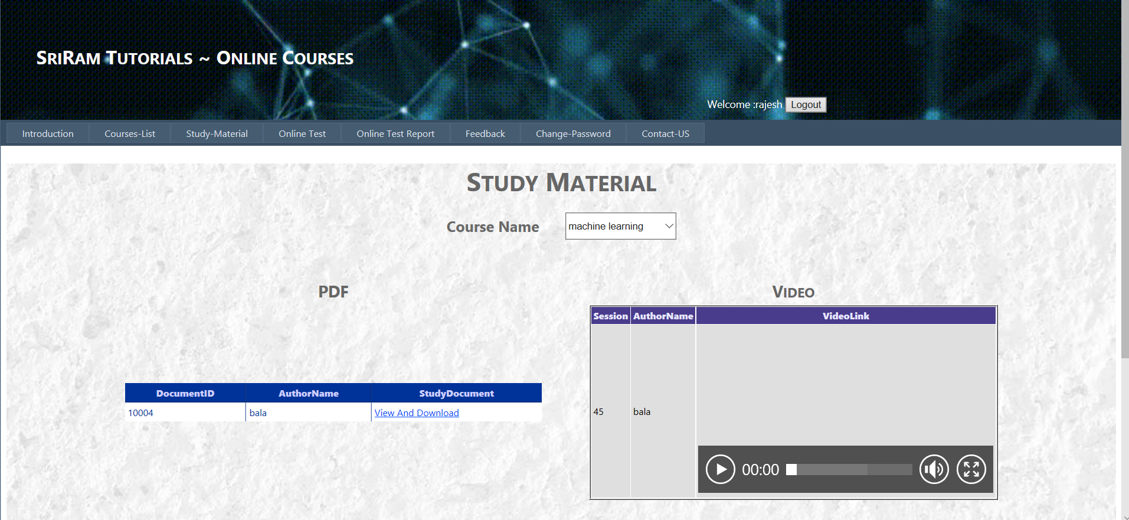

**OnlineTestForStudent.aspx**

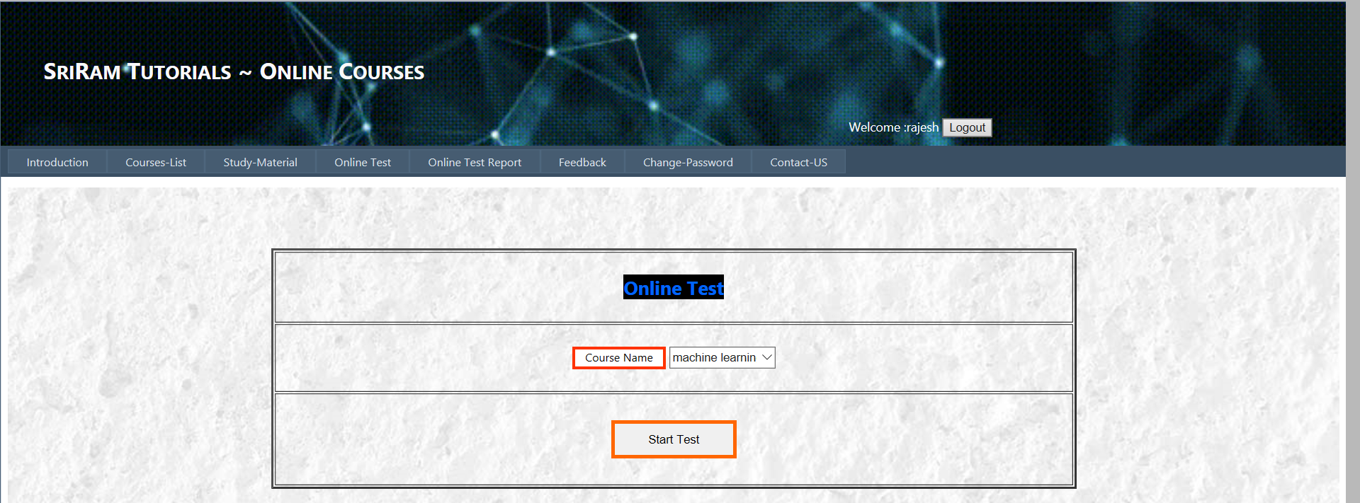

**BeginJavaTest.aspx**

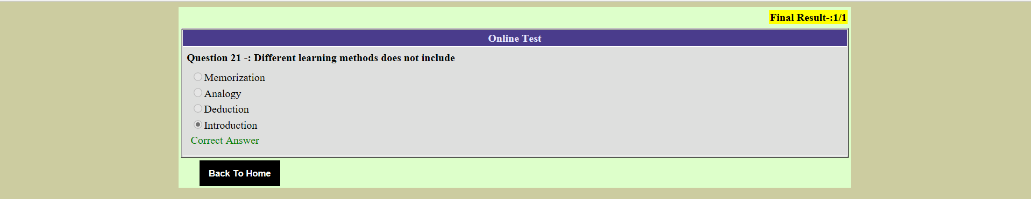

**ViewTestResult.aspx**

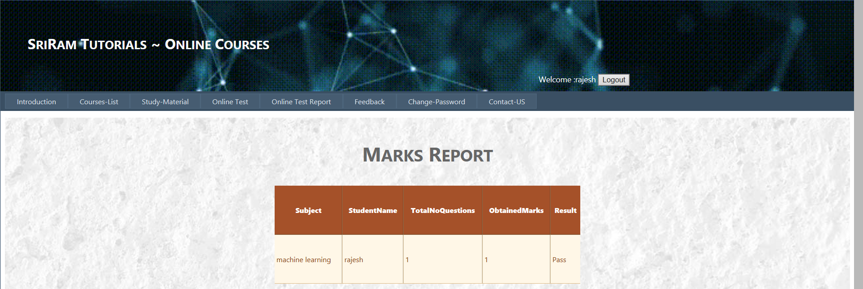

**FeedBack.aspx**

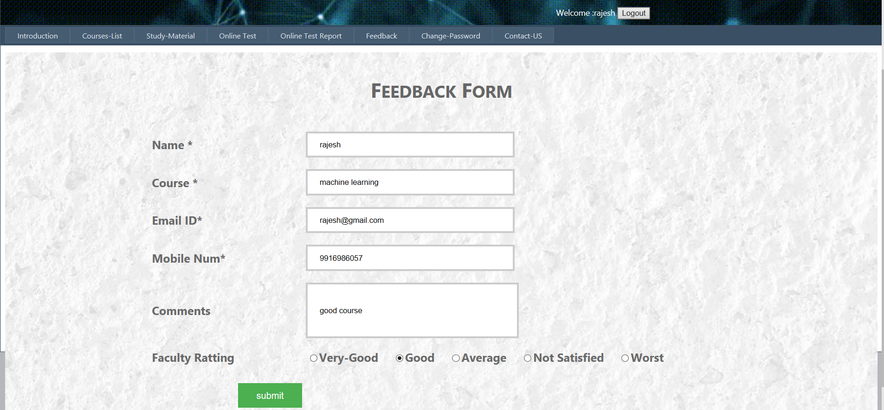

**ViewFeedBack.aspx**

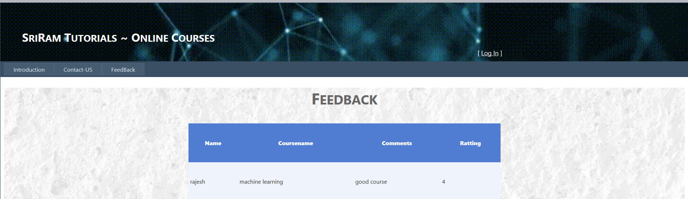

1. **FUTURE ENHANCEMENT**

The following section describes the work that will be implemented with future releases of the software.

* To send notifications through email to the students.
* Add different payment options as PayPal, Gift Cards etc.
* To provide login with e-mail.
* Enhance User Interface by adding more user interactive features.

1. **CONCLUSION**

In the modern world, the use of computers and mobile phones is becoming rampant. So this proposed system needs to embrace these new technologies. This report has presented a simple, convenient, cost effective, but efficient “online course portal” with user-friendly, sensitive and intelligible web interface. Whereby it can be accessed at any time provided there is internet connection.

**10.APPENDIX**

**10.1 SOURCE CODE**

**IntraductionLogin.aspx**

<%@ Page Title="" Language="C#" MasterPageFile="~/Login.master" AutoEventWireup="true" CodeFile="IntraductionLogin.aspx.cs" Inherits="IntraductionLogin" %>

<asp:Content ID="Content1" ContentPlaceHolderID="HeadContent" Runat="Server">

</asp:Content>

<asp:Content ID="Content2" ContentPlaceHolderID="MainContent" Runat="Server">

<!DOCTYPE html>

<html >

<!--<![endif]-->

<head>

<link rel='stylesheet' id='custom-style-css' href='https://www.geeksforgeeks.org/wp-content/themes/iconic-one/css/gfg.min.css?ver=5.6' type='text/css' media='all' />

</head>

<body>

<header id="masthead" class="site-header" role="banner">

<nav id="site-navigation" class="themonic-nav" role="navigation">

<div class="menu-iconic-container"><ul id="menu-top" class="nav-menu">

<li id="menu-item-141975" class="menu-item menu-item-type-custom menu-item-object-custom menu-item-has-children menu-item-141975"><a>

Welcome to Online study center</a>

</li>

</ul></div> </nav><!-- #site-navigation -->

<div class="clear"></div>

</header><!-- #masthead -->

<div id="main" class="wrapper">

<div class="leftSideBarParent">

<table>

<tr>

<img src="images/SR.jpg " width="100px" height="200px"/></tr>

&nbsp&nbsp&nbsp&nbsp&nbsp&nbsp&nbsp&nbsp&nbsp&nbsp

<tr>

<asp:Label ID="Label1" runat="server" Text="Welcome to SriRama Tutorials"

Font-Bold="True" Height="30px"></asp:Label>

<div class="divclass">

<a title="Medium" style="background-repeat: repeat"><span class="articleRating alignright level-3" style="width:170px">SriRama Tutorials</span></a>

</div>

</tr>

</table>

</div>

<div id="primary" class="site-content" style="width:700px">

<article id="post-152831" class="post-152831 post type-post status-publish format-standard sticky hentry category-articles tag-interview-preparation tag-placement-preparation">

<header class="entry-header">

<div class="divclass">

<a title="Medium"><span class="articleRating alignright level-3" style="width:660px">~ ~ ~ ~ ~ ~ Educational Websites for Taking Online Courses ~ ~ ~ ~ ~</span></a>

</div>

<h2 class="entry-title">

<a title="Permalink to Must Do Coding Questions for Companies like Amazon, Microsoft, Adobe, &#8230;" rel="bookmark">There are all sorts of online courses you can take to improve your knowledge and skills</a>

</h2>

</header>

<div class="entry-summary">

<!-- Ico nic One home page thumbnail with custom excerpt -->

<div class="excerpt-thumb">

</div>

<p style="width:675px">Back in the day, if you wanted to learn something new, you'd go to school for it. Today, not only are educational institutions offering their full programs and individual courses online, but experts in almost every field imaginable are creating their own programs and courses online to share their knowledge with their worldwide audiences.

Both educational institutions and individual experts who want to offer their courses online need somewhere to host it and get it out to people who want to learn, which is why there are now so many platforms that are completely dedicated to offering online courses. Some focus on tighter niches like green technology while others include courses in a wide variety of fields.

Whatever you're interested in learning, chances are you can almost certainly find a course about it from the educational course sites listed below. From beginner levels all the way to intermediate and advanced, there's bound to be something for everybody.<span class="read-more"></span></p>

</div><!-- .entry-summary -->

<!-- .entry-meta -->

</article><!-- #post -->

<div class="divclass">

<a title="Medium" href="Login.aspx"><span class="articleRating alignright level-3" style="width:100px">Log-In</span></a>

</div>

</div></div>

</body>

</html>

</asp:Content>

**AddContactDetails.aspx**

<%@ Page Title="" Language="C#" MasterPageFile="~/Admin.master" AutoEventWireup="true" CodeFile="AddContactDetails.aspx.cs" Inherits="AddContactDetails" %>

<asp:Content ID="Content1" ContentPlaceHolderID="HeadContent" Runat="Server">

<style>

input[type=text] {

width: 100%;

padding: 12px 20px;

margin: 8px 0;

box-sizing: border-box;

border: 3px solid #ccc;

-webkit-transition: 0.5s;

transition: 0.5s;

outline: none;

}

input[type=text]:focus {

border: 3px solid #555;

}

.button {

background-color: #4CAF50; /* Green */

border: none;

color: white;

padding: 15px 32px;

text-align: center;

text-decoration: none;

display: inline-block;

font-size: 16px;

margin: 4px 2px;

cursor: pointer;

-webkit-transition-duration: 0.4s; /* Safari */

transition-duration: 0.4s;

}

.button2:hover {

box-shadow: 0 12px 16px 0 rgba(0,0,0,0.24),0 17px 50px 0 rgba(0,0,0,0.19);

}

</style>

</asp:Content>

<asp:Content ID="Content2" ContentPlaceHolderID="MainContent" Runat="Server">

&nbsp&nbsp&nbsp&nbsp&nbsp&nbsp&nbsp&nbsp&nbsp&nbsp;<center><h1 style="font-size:35px;"><b>Add Contact Details</b></h1><br /> <br />

<div>

<table>

<tr> <td>

<asp:Label ID="disp" runat="server" Text=""></asp:Label> </td></tr>

<tr>

<td style="font-size:20px;"><b>Location Name</b></td><td></td>

<td>

<asp:TextBox ID="txtLocation" runat="server" type="text"></asp:TextBox></td>

<td><asp:RequiredFieldValidator ID="RequiredFieldValidator2"

Display="Dynamic" runat="server" ErrorMessage="Location Name required" ControlToValidate="txtLocation"

ValidationGroup="submit"></asp:RequiredFieldValidator> </td></tr>

<tr>

<td style="font-size:20px;"><b>Contact Number</b></td><td></td>

<td>

<asp:TextBox ID="txtCnum" runat="server" type="text"></asp:TextBox></td>

<td><asp:RequiredFieldValidator ID="RequiredFieldValidator1"

Display="Dynamic" runat="server" ErrorMessage="Mobile Number required" ControlToValidate="txtCnum"

ValidationGroup="submit"></asp:RequiredFieldValidator> </td></tr>

<tr>

<td style="font-size:20px;"><b>Email ID</b></td><td></td>

<td>

<asp:TextBox ID="txtEmail" runat="server" type="text"></asp:TextBox></td>

<td><asp:RequiredFieldValidator ID="RequiredFieldValidator3"

Display="Dynamic" runat="server" ErrorMessage="Email ID required" ControlToValidate="txtEmail"

ValidationGroup="submit"></asp:RequiredFieldValidator> </td></tr>

<tr>

<td style="font-size:20px;"><b>Land Line Number</b></td><td></td>

<td>

<asp:TextBox ID="txtLand" runat="server" type="text"></asp:TextBox></td>

<td><asp:RequiredFieldValidator ID="RequiredFieldValidator4"

Display="Dynamic" runat="server" ErrorMessage="Land Line Number required" ControlToValidate="txtLand"

ValidationGroup="submit"></asp:RequiredFieldValidator> </td></tr>

<tr>

<td><br /><br />&nbsp;&nbsp;&nbsp;&nbsp;&nbsp;&nbsp;&nbsp;&nbsp;&nbsp;&nbsp;&nbsp;&nbsp;&nbsp;&nbsp;&nbsp;&nbsp;&nbsp;&nbsp;

&nbsp;&nbsp;&nbsp;&nbsp;&nbsp;&nbsp;&nbsp;&nbsp;&nbsp;&nbsp;&nbsp;&nbsp;&nbsp;&nbsp;&nbsp;&nbsp;&nbsp;&nbsp;

<asp:Button ID="fldsubmit" runat="server" Text="Submit" ValidationGroup="submit" onclick="fldsubmit_Click" CssClass="button button2" /></td>

<td><br /><br />&nbsp;&nbsp;&nbsp;&nbsp;&nbsp;&nbsp;&nbsp;&nbsp;&nbsp;&nbsp;&nbsp;&nbsp;&nbsp;&nbsp;&nbsp;&nbsp;&nbsp;&nbsp;

<asp:Button ID="fldcancle" runat="server" Text="Cancel" onclick="fldcancle_Click" CssClass="button button2" />

</td></tr>

</table>

</div>

</center>

</asp:Content>

}

**AddCourse.aspx**

<%@ Page Title="" Language="C#" MasterPageFile="~/Admin.master" AutoEventWireup="true" CodeFile="AddCourse.aspx.cs" Inherits="AddCourse" %>

<%@ Register Assembly="AjaxControlToolkit" Namespace="AjaxControlToolkit" TagPrefix="asp" %>

<asp:Content ID="Content1" ContentPlaceHolderID="HeadContent" Runat="Server">

<style>

input[type=text] {

width: 100%;

padding: 12px 20px;

margin: 8px 0;

box-sizing: border-box;

border: 3px solid #ccc;

-webkit-transition: 0.5s;

transition: 0.5s;

outline: none;

}

input[type=text]:focus {

border: 3px solid #555;

}

.button {

background-color: #4CAF50; /* Green */

border: none;

color: white;

padding: 15px 32px;

text-align: center;

text-decoration: none;

display: inline-block;

font-size: 16px;

margin: 4px 2px;

cursor: pointer;

-webkit-transition-duration: 0.4s; /* Safari */

transition-duration: 0.4s;

}

.button2:hover {

box-shadow: 0 12px 16px 0 rgba(0,0,0,0.24),0 17px 50px 0 rgba(0,0,0,0.19);

}

</style>

</asp:Content>

<asp:Content ID="Content2" ContentPlaceHolderID="MainContent" Runat="Server">

<asp:ToolkitScriptManager ID="ToolkitScriptManager1" runat="server">

</asp:ToolkitScriptManager>

&nbsp&nbsp&nbsp&nbsp&nbsp&nbsp&nbsp&nbsp&nbsp&nbsp<center><h1 style="font-size:35px;"><b>Add Course</b></h1><br /> <br />

<div>

<table>

<tr> <td>

<asp:Label ID="disp" runat="server" Text=""></asp:Label> </td></tr>

<tr>

<td style="font-size:20px;"><b>Course Name</b></td><td></td>

<td>

<asp:TextBox ID="txtCourseName" runat="server" type="text"></asp:TextBox></td>

<td><asp:RequiredFieldValidator ID="RequiredFieldValidator2"

Display="Dynamic" runat="server" ErrorMessage="Course Name required" ControlToValidate="txtCourseName"

ValidationGroup="submit"></asp:RequiredFieldValidator> </td></tr>

<tr><td style="font-size:20px;"><b>Fee Of Course</b></td><td></td>

<td>

<asp:TextBox ID="txtFee" runat="server" type="text"></asp:TextBox></td>

<td><asp:RequiredFieldValidator ID="RequiredFieldValidator3"

Display="Dynamic" runat="server" ErrorMessage="Fees is required" ControlToValidate="txtFee"

ValidationGroup="submit"></asp:RequiredFieldValidator> </td></tr>

<tr><td style="font-size:20px;"><b>Start Date(dd/mm/yyyy) </b></td><td></td>

<td><asp:TextBox ID="frmDate" runat="server" type="text"></asp:TextBox>

<asp:CalendarExtender ID="CalendarExtender2" runat="server"

TargetControlID="frmDate" Enabled="true" Format="yyyy/MM/dd">

</asp:CalendarExtender></td></tr>

<tr><td style="font-size:20px;"><b>To Date(dd/mm/yyyy) </b></td><td></td>

<td><asp:TextBox ID="txtTo" runat="server" type="text"></asp:TextBox>

<asp:CalendarExtender ID="CalendarExtender1" runat="server"

TargetControlID="txtTo" Enabled="true" Format="yyyy/MM/dd">

</asp:CalendarExtender></td>

</tr>

<tr>

<td><br /><br />&nbsp;&nbsp;&nbsp;&nbsp;&nbsp;&nbsp;&nbsp;&nbsp;&nbsp;&nbsp;&nbsp;&nbsp;&nbsp;&nbsp;&nbsp;&nbsp;&nbsp;&nbsp;

&nbsp;&nbsp;&nbsp;&nbsp;&nbsp;&nbsp;&nbsp;&nbsp;&nbsp;&nbsp;&nbsp;&nbsp;&nbsp;&nbsp;&nbsp;&nbsp;&nbsp;&nbsp;

<asp:Button ID="fldsubmit" runat="server" Text="Submit" ValidationGroup="submit" onclick="fldsubmit_Click" CssClass="button button2" /></td>

<td><br /><br />&nbsp;&nbsp;&nbsp;&nbsp;&nbsp;&nbsp;&nbsp;&nbsp;&nbsp;&nbsp;&nbsp;&nbsp;&nbsp;&nbsp;&nbsp;&nbsp;&nbsp;&nbsp;

<asp:Button ID="fldcancle" runat="server" Text="Cancel" onclick="fldcancle_Click" CssClass="button button2" />

</td></tr>

</table>

</div>

</center>

</asp:Content>

**AdminChangePassword1.aspx**

<%@ Page Title="" Language="C#" MasterPageFile="~/Admin.master" AutoEventWireup="true" CodeFile="ChangePasswordAdmin.aspx.cs" Inherits="ChangePassword1" %>

<asp:Content ID="Content1" ContentPlaceHolderID="HeadContent" Runat="Server">

<style>

input[type=password] {

width: 100%;

padding: 12px 20px;

margin: 8px 0;

box-sizing: border-box;

border: 3px solid #ccc;

-webkit-transition: 0.5s;

transition: 0.5s;

outline: none;

}

input[type=password]:focus {

border: 3px solid #555;

}

.button {

background-color: #4CAF50; /* Green */

border: none;

color: white;

padding: 12px 32px;

text-align: center;

text-decoration: none;

display: inline-block;

font-size: 16px;

margin: 4px 2px;

cursor: pointer;

-webkit-transition-duration: 0.4s; /* Safari */

transition-duration: 0.4s;

}

.button2:hover {

box-shadow: 0 12px 16px 0 rgba(0,0,0,0.24),0 17px 50px 0 rgba(0,0,0,0.19);

}

</style>

</asp:Content>

<asp:Content ID="Content2" ContentPlaceHolderID="MainContent" Runat="Server">

&nbsp&nbsp&nbsp&nbsp&nbsp&nbsp&nbsp&nbsp&nbsp&nbsp<center><h1 style="font-size:35px;"><b>Change Password</b></h1><br /> <br />

<table>

<tr> <td><asp:Label ID="lblmsg" runat="server" Text=""></asp:Label> </td></tr>

<tr><td style="font-size:20px;"><b>Old Password</b></td><td></td>

<td>

<asp:TextBox ID="fldoldpwd" runat="server"

TextMode="Password" type="text"></asp:TextBox>

<asp:RequiredFieldValidator ID="RequiredFieldValidator2" runat="server"

ControlToValidate="fldoldpwd" ErrorMessage="Old password required"

ValidationGroup="submit"></asp:RequiredFieldValidator>

</td></tr>

<tr><td style="font-size:20px;"><b>New Password</b></td><td></td>

<td>

<asp:TextBox ID="fldnewpwd" runat="server"

TextMode="Password" type="text"></asp:TextBox>

<asp:RequiredFieldValidator ID="RequiredFieldValidator1" runat="server"

ControlToValidate="fldnewpwd" ErrorMessage="Password should not be empty "

ValidationGroup="submit"></asp:RequiredFieldValidator>

</td></tr>

<tr><td style="font-size:20px;"><b>Confirm Password</b></td><td></td>

<td>

<asp:TextBox ID="fldcnpwd" runat="server"

TextMode="Password" type="text"></asp:TextBox>

<asp:CompareValidator ID="CompareValidator1" runat="server"

ControlToCompare="fldnewpwd" ControlToValidate="fldcnpwd"

ErrorMessage="Password did not match" ValidationGroup="submit"></asp:CompareValidator>

</td></tr>

<tr><td></td><td><br/></br/>

<asp:Button ID="cpsubmit" runat="server" Text="Submit"

onclick="cpsubmit_Click" ValidationGroup="submit" CssClass="button button2" /></td></tr>

</table></center>

</asp:Content>

**AssignCourceToStudent.aspx**

<%@ Page Title="" Language="C#" MasterPageFile="~/Admin.master" AutoEventWireup="true" CodeFile="AssignCourceToStudent.aspx.cs" Inherits="AssignCourceToStudent" %>

<asp:Content ID="Content1" ContentPlaceHolderID="HeadContent" Runat="Server">

<style>

.button {

background-color: #4CAF50; /* Green */

border: none;

color: white;

padding: 10px 24px;

text-align: center;

text-decoration: none;

display: inline-block;

font-size: 16px;

margin: 4px 2px;

cursor: pointer;

-webkit-transition-duration: 0.4s; /* Safari */

transition-duration: 0.4s;

}

.button2:hover {

box-shadow: 0 12px 16px 0 rgba(0,0,0,0.24),0 17px 50px 0 rgba(0,0,0,0.19);

}

</style>

</asp:Content>

<asp:Content ID="Content2" ContentPlaceHolderID="MainContent" Runat="Server">

<center><h1 style="font-size:35px;"><b> Assign Courses to student</b></h1><br />

<div>

<table>

<tr>

<td style="font-size:20px;"><b>Course list</b></td><td></td>

<td> <asp:DropDownList ID="ddlCourseSelect" runat="server" AutoPostBack="True"

DataSourceID="SqlDataSource2" DataTextField="CourseName"

DataValueField="CourseName"

onselectedindexchanged="ddlCourseSelect_SelectedIndexChanged"

Width="200px" Height="40px">

</asp:DropDownList>

<asp:SqlDataSource ID="SqlDataSource2" runat="server"

ConnectionString="<%$ ConnectionStrings:OnlineStudyBookConnectionString %>"

SelectCommand="SELECT [CourseName] FROM [AddCourse] WHERE ([delrec] = @delrec)">

<SelectParameters>

<asp:Parameter DefaultValue="N" Name="delrec" Type="String" />

</SelectParameters>

</asp:SqlDataSource>

</td></tr>

<tr>

<td style="font-size:20px;"><b>Student Name</b></td><td></td>

<td><asp:DropDownList ID="ddlstudentSelection" runat="server" Width="200px" Height="40px">

</asp:DropDownList></td></tr>

<tr><td></td> <td><br /><asp:Button ID="btnSave" runat="server" Text="Submit" CssClass="button button2"

onclick="btnSave_Click" Width="142px" /> </td></tr>

</table></div></center>

<h1 style="font-size:35px;"><b>student Details</b></h1><br />

<table><tr> <td>

<asp:Label ID="disp" runat="server" Text=""></asp:Label> </td></tr></table>

<asp:GridView ID="GridView1" runat="server" AllowPaging="True"

AutoGenerateColumns="False" DataKeyNames="pid"

DataSourceID="SqlDataSource1" CellPadding="4" ForeColor="#333333"

GridLines="None" Height="26px" Width="836px">

<AlternatingRowStyle BackColor="White" ForeColor="#284775" />

<Columns>

<asp:CommandField ShowDeleteButton="True" />

<asp:BoundField DataField="pid" HeaderText="pid" ReadOnly="True"

SortExpression="pid" />

<asp:BoundField DataField="CourseName" HeaderText="CourseName"

SortExpression="CourseName" />

<asp:BoundField DataField="Studentname" HeaderText="Studentname"

SortExpression="Studentname" />

<asp:BoundField DataField="Approval" HeaderText="Approval"

SortExpression="Approval" />

<asp:BoundField DataField="assigned" HeaderText="Assigned"

SortExpression="assigned" />

</Columns>

<EditRowStyle BackColor="#999999" />

<FooterStyle BackColor="#5D7B9D" Font-Bold="True" ForeColor="White" />

<HeaderStyle BackColor="#5D7B9D" Font-Bold="True" ForeColor="White" />

<PagerStyle BackColor="#284775" ForeColor="White" HorizontalAlign="Center" />

<RowStyle BackColor="#F7F6F3" ForeColor="#333333" />

<SelectedRowStyle BackColor="#E2DED6" Font-Bold="True" ForeColor="#333333" />

<SortedAscendingCellStyle BackColor="#E9E7E2" />

<SortedAscendingHeaderStyle BackColor="#506C8C" />

<SortedDescendingCellStyle BackColor="#FFFDF8" />

<SortedDescendingHeaderStyle BackColor="#6F8DAE" />

</asp:GridView>

<asp:SqlDataSource ID="SqlDataSource1" runat="server"

ConnectionString="<%$ ConnectionStrings:OnlineStudyBookConnectionString %>"

DeleteCommand="UPDATE paymentdetails SET delrec = 'Y' WHERE pid = @pid"

SelectCommand="SELECT [pid] , [CourseName], [Studentname], [Approval],[Assigned] FROM [paymentdetails] WHERE (([delrec] = @delrec) AND ([Approval] = @Approval) AND ([assigned] = @assigned))">

<DeleteParameters>

</DeleteParameters>

<SelectParameters>

<asp:Parameter DefaultValue="N" Name="delrec" />

<asp:Parameter DefaultValue="Y" Name="Approval" />

<asp:Parameter DefaultValue="No" Name="assigned" />

</SelectParameters>

<UpdateParameters>

</UpdateParameters>

</asp:SqlDataSource>

</asp:Content>

**AssignCOurseToInstractor.aspx**

<%@ Page Title="" Language="C#" MasterPageFile="~/Admin.master" AutoEventWireup="true" CodeFile="AssignCOurseToInstractor.aspx.cs" Inherits="AssignCOurseToInstractor" %>

<asp:Content ID="Content1" ContentPlaceHolderID="HeadContent" Runat="Server">

<style>

.button {

background-color: #4CAF50; /* Green */

border: none;

color: white;

padding: 12px 24px;

text-align: center;

text-decoration: none;

display: inline-block;

font-size: 16px;

margin: 4px 2px;

cursor: pointer;

-webkit-transition-duration: 0.4s; /* Safari */

transition-duration: 0.4s;

}

.button2:hover {

box-shadow: 0 12px 16px 0 rgba(0,0,0,0.24),0 17px 50px 0 rgba(0,0,0,0.19);

}

</style>

</asp:Content>

<asp:Content ID="Content2" ContentPlaceHolderID="MainContent" Runat="Server">

<div style="height:800px; background-image:url(images/wall1.jpg); background-size:cover; background-repeat:no-repeat;">

<div>

<center><h1 style="font-size:35px;"><b>Assign Course To Instructor</b></h1><br /> <br />

<table>

<tr>

<td style="font-size:20px;"><b> Course Name :</b></td><td></td>

<td><asp:DropDownList ID="ddlCourseName" runat="server" AutoPostBack="True" Width="200px" Height="40px"

DataSourceID="SqlDataSource1" DataTextField="CourseName"

DataValueField="CourseName">

</asp:DropDownList>

<asp:SqlDataSource ID="SqlDataSource1" runat="server"

ConnectionString="<%$ ConnectionStrings:OnlineStudyBookConnectionString %>"

SelectCommand="SELECT [CourseName] FROM [AddCourse] WHERE ([CourseAvilable] = @CourseAvilable)">

<SelectParameters>

<asp:Parameter DefaultValue="Yes" Name="CourseAvilable" Type="String" />

</SelectParameters>

</asp:SqlDataSource>

</td></tr>

<tr>

<td style="font-size:20px;"><b> Instructor Name :</b></td><td></td>

<td><asp:DropDownList ID="ddlInstractor" runat="server" AutoPostBack="True" Width="200px" Height="40px"

DataSourceID="SqlDataSource2" DataTextField="uname" DataValueField="uname">

</asp:DropDownList>

<asp:SqlDataSource ID="SqlDataSource2" runat="server"

ConnectionString="<%$ ConnectionStrings:OnlineStudyBookConnectionString %>"

SelectCommand="SELECT [uname] FROM [OnlineStudyBooklogin] WHERE (([delrec] = @delrec) AND ([Etype] = @Etype) AND ([instAvailable] =@instAvailable))">

<SelectParameters>

<asp:Parameter DefaultValue="N" Name="delrec" Type="String" />

<asp:Parameter DefaultValue="I" Name="Etype" Type="String" />

<asp:Parameter DefaultValue="Yes" Name="instAvailable" Type="String" />

</SelectParameters>

</asp:SqlDataSource>

</td></tr>

<tr>

<td>&nbsp;</td>

<td><br /> <asp:Button ID="txtAssigninst" runat="server" Text="Assign" CssClass="button button2"

onclick="txtAssigninst_Click" Width="89px" /></td></tr>

</table></div>

<div><br /><br /><br /><h1 style="font-size:35px;"><b>Instructor Details In Terms of Course</b></h1><br /> <br />

<tabel>

<asp:GridView ID="GridView1" runat="server" AllowPaging="True"

AutoGenerateColumns="False" BackColor="White" BorderColor="#3366CC"

BorderStyle="None" BorderWidth="1px" CellPadding="4"

DataKeyNames="CourseName" DataSourceID="SqlDataSource3" Height="309px"

Width="934px">

<Columns>

<asp:BoundField DataField="CourseName" HeaderText="CourseName"

SortExpression="CourseName" />

<asp:BoundField DataField="InstractorName" HeaderText="InstractorName"

SortExpression="InstractorName" />

<asp:BoundField DataField="CourseAvilable" HeaderText="CourseAvilable"

SortExpression="CourseAvilable" />

<asp:BoundField DataField="FeeOfCourse" HeaderText="FeeOfCourse"

SortExpression="FeeOfCourse" />

</Columns>

<FooterStyle BackColor="#99CCCC" ForeColor="#003399" />

<HeaderStyle BackColor="#003399" Font-Bold="True" ForeColor="#CCCCFF" />

<PagerStyle ForeColor="#003399" HorizontalAlign="Left" BackColor="#99CCCC" />

<RowStyle BackColor="White" ForeColor="#003399" />

<SelectedRowStyle BackColor="#009999" Font-Bold="True" ForeColor="#CCFF99" />

<SortedAscendingCellStyle BackColor="#EDF6F6" />

<SortedAscendingHeaderStyle BackColor="#0D4AC4" />

<SortedDescendingCellStyle BackColor="#D6DFDF" />

<SortedDescendingHeaderStyle BackColor="#002876" />

</asp:GridView>

<asp:SqlDataSource ID="SqlDataSource3" runat="server"

ConnectionString="<%$ ConnectionStrings:OnlineStudyBookConnectionString %>"

SelectCommand="SELECT CourseName, InstractorName, CourseAvilable, FeeOfCourse FROM AddCourse WHERE (delrec = @delrec)"

UpdateCommand="UPDATE AddCourse SET CourseAvilable = 'Yes', InstractorName = NULL WHERE (CourseID = @CourseID) AND (delrec = @delrec)">

<SelectParameters>

<asp:Parameter DefaultValue="N" Name="delrec" />

</SelectParameters>

<UpdateParameters>

<asp:Parameter Name="CourseID" />

<asp:Parameter Name="delrec" />

</UpdateParameters>

</asp:SqlDataSource>

</tabel></div>

</center>

</div>

</div>

</asp:Content>

**BeginJavaTest.aspx.cs**

<%@ Page Language="C#" AutoEventWireup="true" CodeFile="BeginJavaTest.aspx.cs" Inherits="BeginJavaTest" %>

<!DOCTYPE html>

<html xmlns="http://www.w3.org/1999/xhtml">

<head id="Head1" runat="server">

<title></title>

<script src="http://ajax.googleapis.com/ajax/libs/jquery/1.7/jquery.min.js" type="text/javascript"></script>

</head>

<body oncontextmenu="return false" style=" background: #cccca0;">

<form id="form1" runat="server">

<asp:ScriptManager ID="ScriptManger" runat="server"></asp:ScriptManager>

<div style="background: #ddffca;margin:0 auto; width:1000px;">

<asp:UpdatePanel ID="updPanel" runat="server" UpdateMode="Always">

<ContentTemplate>

<table style="width: 100%;">

<tr>

<td>

<table style="width: 100%;">

<tr>

<asp:HiddenField ID="hdn_marksScored" runat="server" />

<asp:HiddenField ID="Hdn_totalQuestions" runat="server" />

<td style="float: left;"><b><span id="timerText"></span><span id="spnthankyou"></span></b></td>

<td style="float: right; background-color: yellow; color: black;"><b><span id="lbresult"></span></b></td>

</tr>

</table>

</td>

</tr>

<tr>

<td>

<asp:GridView ID="grdquestions" runat="server" AutoGenerateColumns="False"

OnRowDataBound="grdquestions_RowDataBound" DataKeyNames="QuestionId"

Width="100%" BackColor="White" BorderColor="White" BorderStyle="Ridge"

BorderWidth="2px" CellPadding="3" CellSpacing="1" GridLines="None">

<Columns>

<asp:TemplateField HeaderText="Online Test">

<ItemTemplate>

<table class="tableclass" id='<%#Eval("QuestionId") %>'>

<tr>

<td><b>Question <%#Eval("QuestionId") %> -: <%#Eval("Question") %></b>

<asp:HiddenField ID="hdnquestionId" runat="server"/>

</td>

</tr>

<tr>

<td>

<table>

<tr>

<td>

<table class="tblOptions">

<tr>

<td>

<asp:RadioButton ID="rdOption1" runat="server" Text='<%#Eval("Option1") %>' GroupName='<%#Eval("QuestionId") %>' />

</td>

</tr>

<tr>

<td>

<asp:RadioButton ID="rdOption2" runat="server" Text='<%#Eval("Option2") %>' GroupName='<%#Eval("QuestionId") %>' />

</td>

</tr>

<tr>

<td>

<asp:RadioButton ID="rdOption3" runat="server" Text='<%#Eval("Option3") %>' GroupName='<%#Eval("QuestionId") %>' /></td>

</tr>

<tr>

<td>

<asp:RadioButton ID="rdOption4" runat="server" Text='<%#Eval("Option4") %>' GroupName='<%#Eval("QuestionId") %>' /></td>

</tr>

<tr>

<td>

<asp:Label ID="lbquestionstatus" runat="server"></asp:Label>

</td>

</tr>

<tr>

<td class="correctAnswer">Correct Answer Is -:

<asp:Label ID="lbAnswer" runat="server" Text='<%#Eval("QuestionAnswer") %>'></asp:Label>

</td>

</tr>

</table>

</td>

</tr>

</table>

</td>

</tr>

</table>

</ItemTemplate>

</asp:TemplateField>

</Columns>

<FooterStyle BackColor="#C6C3C6" ForeColor="Black" />

<HeaderStyle BackColor="#4A3C8C" Font-Bold="True" ForeColor="#E7E7FF" />

<PagerStyle BackColor="#C6C3C6" ForeColor="Black" HorizontalAlign="Right" />

<RowStyle BackColor="#DEDFDE" ForeColor="Black" />

<SelectedRowStyle BackColor="#9471DE" Font-Bold="True" ForeColor="White" />

<SortedAscendingCellStyle BackColor="#F1F1F1" />

<SortedAscendingHeaderStyle BackColor="#594B9C" />

<SortedDescendingCellStyle BackColor="#CAC9C9" />

<SortedDescendingHeaderStyle BackColor="#33276A" />

</asp:GridView>

</td>

</tr>

<tr>

<td>

<asp:Button ID="btnSubmit" runat="server" Text="Submit" CssClass="btn" Visible="false" OnClientClick="return CheckIfAllQuestionAnswerHasBeenSubmitted()"/>

&nbsp&nbsp&nbsp&nbsp&nbsp&nbsp

<asp:Button ID="btnSave" runat="server" Text="Back To Home" BackColor="Black" BorderColor="Black" Font-Bold="True" ForeColor="White"

Height="38px" Width="120px" BorderStyle="Solid" onclick="btnSave_Click" />

</td>

</td>

</tr>

</table>

</ContentTemplate>

</asp:UpdatePanel>

<script>

//Set the number of minutes you need

var mins = 1;

var secs = mins * 60;

var currentSeconds = 0;

var currentMinutes = 0;

var ourtimer;

function StartCountDown() {

ourtimer = setTimeout(Decrement, 1000);

}

function EndCountDown() {

clearTimeout(ourtimer);

}

$(document).ready(function () { StartCountDown(); }); //start the countdown

function Decrement() {

currentMinutes = Math.floor(secs / 60);

currentSeconds = secs % 60;

if (currentSeconds <= 9) currentSeconds = "0" + currentSeconds;

secs--;

document.getElementById("timerText").innerHTML = "Time Remaining " + currentMinutes + ":" + currentSeconds;

if (secs !== -1) {

setTimeout('Decrement()', 1000);

}

else {

window.location.href = "OnlineTestForStudent.aspx?timeout=1"

}

}

function CheckIfAllQuestionAnswerHasBeenSubmitted() {

var numItems = $('.tblOptions').length;

var flagtocheckcount = 0;

$(".tblOptions").each(function () {

var groupname = $('input[type=radio]:first', this).attr('name');

if (!$("input[name='" + groupname + "']:checked").val()) {

$(this).parents(".tableclass").addClass("border");

var tableid = $(this).closest('table [class^="tableclass"]').attr("id");

}

else {

flagtocheckcount = flagtocheckcount + 1;

}

})

if (parseInt(flagtocheckcount) == parseInt(numItems)) {

var CountFinalResult = 0;

$(".tblOptions").each(function () {

var groupname = $('input[type=radio]:first', this).attr('name');

var radioId = $("input[name='" + groupname + "']:checked").attr("id")

var UserSelectedAnswer = $("label[for='" + radioId + "']").text();

var CorrectAnswer = $('span:last-child', this).text();

var CorrectAnswerSpanId = $('span:last-child', this).attr("id");

var QuestionStatus = $("span:nth-last-child(1)", this).attr("id");

if (CorrectAnswer == UserSelectedAnswer) {

$("#" + QuestionStatus).text("Correct Answer").css("color", "green");

$('td.correctAnswer').find("td.correctAnswer", this).css("display", "none");

CountFinalResult = CountFinalResult + 1;

}

else {

//$('table.tblOptions tbody tr td:last-child').addClass("incorrect");

$('span:last-child', this).css({ 'display': 'inline-flex' });

$("#" + QuestionStatus).text("InCorrect Answer").css({ 'color': 'Red' });

$('td.correctAnswer', this).css({ "display": "block", "background-color": "yellow", "color": "red" });

}

});

document.getElementById('Hdn_totalQuestions').value = flagtocheckcount;

alert("Total Number OF questions questions count::::" + document.getElementById('Hdn_totalQuestions').value);

$("#lbresult").text("Final Result-:" + CountFinalResult + "/" + flagtocheckcount);

document.getElementById('hdn_marksScored').value = CountFinalResult;

alert("answered questions count::::" + document.getElementById('hdn_marksScored').value);

// $("#btnSubmit").attr("Enabled",true); //disable button if all questions answer has been given

//$("#btnSubmit").removeClass("btn");

$("#btnSubmit").addClass("btndiabled");

EndCountDown();

$("#timerText").css("display", "none");

//$("#spnthankyou").append("Thank You for submitting your test.")

$("input[type=radio]").attr('disabled', true); //disable all radio button after test submitted by user

return false;

}

else {

return false;

}

}

var CountCheckCheckQuestion = 0; //following function will work on every radio button click

var TotalQuestions = 0;

$("input[type=radio]").click(function () {

var groupname = $(this).attr("name");

$(this).parents(".tableclass").removeClass("border");

CheckTheCountOfQuestionHasBeenAnswered(); //this function to check if all the answer given while selecting radio button you don't need..

// to click on submit button

if (parseInt(CountCheckCheckQuestion) == parseInt(TotalQuestions)) {

CheckIfAllQuestionAnswerHasBeenSubmitted();

}

});

function CheckTheCountOfQuestionHasBeenAnswered() {

TotalQuestions = $('.tblOptions').length;

var TotalGivenAnswerCount = 0;

var flagtocheckcount = 0;

$(".tblOptions").each(function () {

var groupname = $('input[type=radio]:first', this).attr('name');

if (!$("input[name='" + groupname + "']:checked").val()) {

}

else {

TotalGivenAnswerCount = TotalGivenAnswerCount + 1;

}

})

CountCheckCheckQuestion = TotalGivenAnswerCount;

}

</script>

<style>

.border {

border-color: red;

border-width: 2px;

border-style: solid;

width: 100%;

}

.correctAnswer {

display: none;

width: 950px!important;

}

.tblOptions {

width: 100%;

}

.btn {

background: #000000;

background-image: -webkit-linear-gradient(top, #000000, #2980b9);

background-image: -moz-linear-gradient(top, #000000, #2980b9);

background-image: -o-linear-gradient(top, #000000, #2980b9);

background-image: linear-gradient(to bottom, #000000, #2980b9);

-webkit-border-radius: 0;

-moz-border-radius: 0;

border-radius: 6px;

font-family: Arial;

color: #ffffff;

font-size: 19px;

padding: 3px 20px;

text-decoration: none;

}

.btn:hover {

background: #261c61;

background-image: -webkit-linear-gradient(top, #261c61, #3498db);

background-image: -moz-linear-gradient(top, #261c61, #3498db);

background-image: -o-linear-gradient(top, #261c61, #3498db);

background-image: linear-gradient(to bottom, #261c61, #3498db);

text-decoration: none;

cursor: pointer;

}

.btndiabled {

background: #bdb3bd;

background-image: -webkit-linear-gradient(top, #bdb3bd, #757575);

background-image: -moz-linear-gradient(top, #bdb3bd, #757575);

background-image: -o-linear-gradient(top, #bdb3bd, #757575);

background-image: linear-gradient(to bottom, #bdb3bd, #757575);

-webkit-border-radius: 0;

-moz-border-radius: 0;

border-radius: 6px;

font-family: Arial;

color: #ffffff;

font-size: 19px;

padding: 3px 20px;

text-decoration: none;

cursor: none;

}

</style>

</div>

</form>

</body>

</html>

**11.BIBLIOGRAPGY**

* https://www.c-sharpcorner.com/article/how-to-create-login-page-in-asp-net-web-application-using-c-sharp-and-sql-server/
* https://www.codeproject.com/Articles/21480/Video-Uploader-Control-for-SQL-Server
* https://vkinfotek.com/gridview/button-fields-gridview-control.html
* https://archive.codeplex.com/?p=onlinequiz